DBMS LAB ASSIGNMENT 4: Built-in-Functions

1. WAQ to display the current date.

2. Assume that employees serve a six month provisional period starting from their DOJ. After 6 months they get permanent status. Display all the employees’ names, doj and the date on which they received their permanent status as permanent_date.

3. WAQ to display the last date of this current month.

4. For all the employees display their emp_id, f_name and their total experience in months.

5. WAQ to display the date of next TUESDAY.

6. WAQ to extract the current month.

7. WAQ to extract the current year.

8. WAQ to display the absolute value of -505.

9. WAQ to display the ceiling of 10.44 and 10.50 and 10.65.

10. WAQ to display the floor value of 10.44 and 10.50 and 10.65.

11. Find the logarithmic value of 10 base 2.

12. Display the remainder in 594/7.

13. WAQ to display the value of 8 to the power 3.

14. WAQ to display the square root of 3481.

15. Display the following rounding operations- round(45.923,2), round(45.923,0), round(45.923,-1), round(45.923,2), round(45.923,0), round(45.923,-2).

16. Display the following rounding operations- trunc(45.888,2), trunc(56.758,0), trunc(49.245,-2), trunc(45.888,2), round(45.888,2).

17. WAQ to return the sign of 20 and -67.60 and 0.

18. Display the value of cos(45), sin(45), and tan(45).

19. Display the ASCII character corresponding to the integer 79.

20.Display the f_name and l_name together using the concat() function.

21. Display all the f_names in capital letters.

22. Find the length of the first name and last name of all the employees who work in sales department.

23. . Determine the tax-rate for each employee based on their monthly salary. The tax-rates are as per the following table.

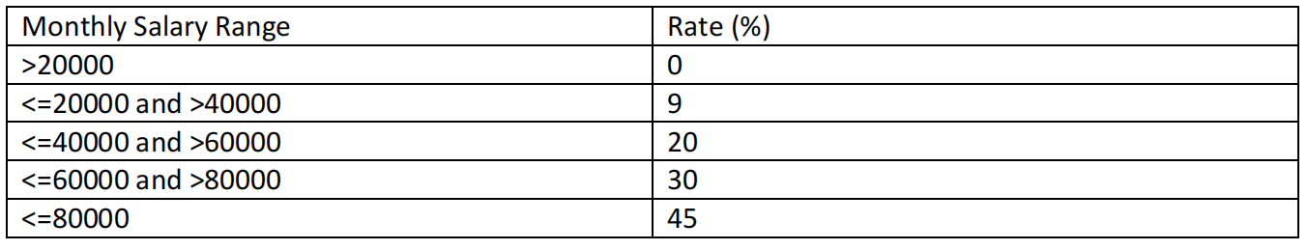

24. Find the average salary, maximum salary, minimum salary and the sum of salaries from the employee table.

25. Find the average salary, maximum salary, minimum salary and the sum of salaries of the employees who work for the sales department.

26.  Find the newest and oldest employee.

27. Find those two employees whose l_name comes first and last in alphabetical order.

28. Find the number of engineers.

29. Find the number of departments from the employee table.

30. Find the average commission from the employee table.